

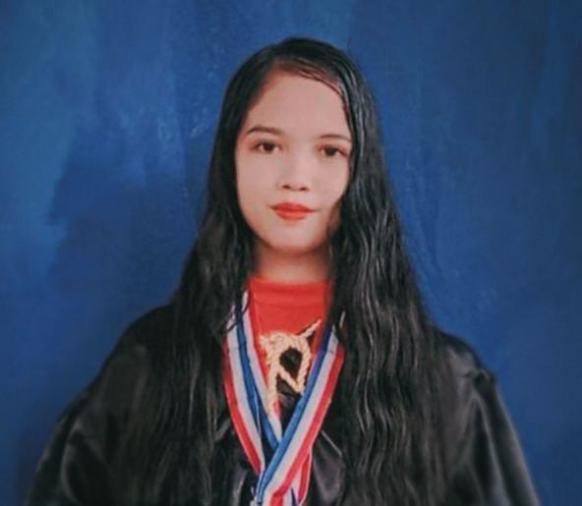
SKILLS
College:
MISAMIS UNIVERSITY OF OZAMIZ CITY
Immaculate Conception College-La Salle
Bachelor of Science in Accountancy (Graduated)
March, 2023-2027
Secondary: OZAMIZ CITY NATIONAL HIGH SCHOOL
Bernad St., Lam-an, Ozamiz City
April 2018-2023
Computer Literate (MS Word, Power Point). Proficient in Oral
and Written Communication Skills Fast learner, hardworking
and committed to excellence. Willing to learn new task
EDUCATION
WITH HIGH HONORS STUDENT
GIRLS SCOUT OF THE YEAR
BEST IN READING AND WRITING
OUTSTANDING STUDENT OF THE YEAR
I am a dedicated, loyal person who
works hard. I am a fast learner and
always up for a challenge. I work well
with others, while also working
consistently on my own. I am seeking
a position where I can develop and
learn while giving my best to an
employer. To enhance my potentials
to the fullest, and to provide quality
service to my chosen field of
endeavor by being effective and
productive employee.not afraid of
difficulties, dare to meet challenges,
for new things to accept the ability to
be strong, life and work attitude
positive, hope to improve their own
continuous progress.
AWARDS/CERTIFICATE
Age:
24 years old
Date of Birth:
March 05, 2005
Place of Birth:
Aromahon, Laguindingan, Misamis
Oriental
Height:
5'1
Weight:
42 klg
Civil Status:
Single
Religion:
Catholic
Nationality:
Filipino
HR & A D MI NI S T R ATI V E
Zone 6, Aromahon, Lagundingan,
Misamis Oriental
9018, Mindanao Philippines
Email Address:
queenstephanie@gmail.com
Contact Number:
Mobile No.: 09106370493
Queen Stephanie C.Betonio
Call Center Representative
WORK EXPERIENCE
1.
Student
Office
Assistant
at
Cagayan
De
Oro
College.
2.
Data Encode and Programmer at Department of
Information
and
Communication
Technology
(DICT) office during on the job training.
PERSONAL BACKROUND
CHARACTER REFERENCES
1.
MRS. JANNETH L. VILLAVICENCIO
Steel Town Subdivision, Iligan City
Mobile No. 09261412118
2.
MR. EDWARD A. JARALES
Initao, Misamis Oriental
Mobile No. 09185212652
3.
MRS. MARY JOY D. SABELLA
Zone
3,
Poblacion,
Laguindingan,
Misamis Oriental
Mobile No. 0926141580
POSITION DESIRED
DESCRIPTION

